
SESHADRIPURAM EDUCATIONAL TRUST
SESHADRIPURAM COLLEGE
POST GRADUATE DEPARTMENT OF COMPUTER APPLICATIONS
#27, Nagappa Street, Seshadripuram, Bengaluru – 560020
PERMANENTLY AFFILIATED TO
DR. MANMOHAN SINGH BENGALURU CITY UNIVERSITY | AICTE APPROVED
ISO 9001:2015 CERTIFIED | NAAC GRADE: A++
department.mca@spmcollege.ac.in | https://www.spmcollege.ac.in/mca/

PROJECT REPORT ON
“AI-BASED SKIN UNDERTONE ANALYSIS AND PERSONALIZED FASHION COLOUR RECOMMENDATION SYSTEM”

Submitted in partial fulfillment for the award of degree in
MASTER OF COMPUTER APPLICATIONS (MCA)

IV SEMESTER
Submitted by

Rangapariya Smit Hareshbhai - P18GH24S126068
Under the Guidance of

Prof. Deeksha Holla

Academic Year : 2025-26

CERTIFICATE

This is to certify that the major project entitled “AI-BASED SKIN UNDERTONE ANALYSIS AND PERSONALIZED FASHION COLOUR RECOMMENDATION SYSTEM”, carried out by Rangapariya Smit Hareshbhai (P18GH24S126068) has satisfactorily completed the course of experiments in the practical project for the award of Master of Computer Applications in the Post Graduate Department of Computer Applications, Seshadripuram College, affiliated to Dr. Manmohan Singh Bengaluru City University, during the academic year 2025–26.

Project Guide Incharge Head

Prof. Deeksha Holla Prof. Rajeswari. V

Date:

EXAMINERS

- ..............................................

- ...............................................

DECLARATION

I, Rangapariya Smit Hareshbhai - P18GH24S126068 hereby solemnly declare that the major project entitled “AI-BASED SKIN UNDERTONE ANALYSIS AND PERSONALIZED FASHION COLOUR RECOMMENDATION SYSTEM” is a bonafide work carried out by me under the guidance of Prof. Deeksha Holla, Post Graduate Department of Computer Applications, Seshadripuram College, Bengaluru.
This project, as presented in this report, is my original work and has not been submitted for the award of any other degree or diploma from any other University.
This project has been submitted in partial fulfillment of the requirements for the degree of Master of Computer Applications (MCA) of Dr. Manmohan Singh Bengaluru City University.

Place: Bangalore Date:

Rangapariya Smit Hareshbhai - P18GH24S126068

ACKNOWLEDGEMENT

It gives me immense pleasure to express my heartfelt gratitude to all those who supported and guided me throughout the course of this major project.
I would like to express my sincere thanks to my respected Principal, Maj. Dr. Anandappa I, for providing me with the opportunity and academic environment at Seshadripuram College, which made this endeavor possible.
I extend my deep sense of appreciation to my Incharge Head, Prof. Rajeswari V, Post Graduate Department of Computer Applications, for her continuous encouragement and support during the project.
I take this opportunity to convey my profound gratitude to my Guide, Prof. Deeksha Holla, whose expert guidance, valuable suggestions, and constant motivation played a key role in the successful completion of this project.
Finally, I would like to express my heartfelt thanks to the Almighty, my parents, and my friends for their moral support and encouragement throughout this project.

Rangapariya Smit Hareshbhai P18GH24S126068

Table Of Contents

Abstract

Professional fashion colour analysis - determining which clothing colours genuinely suit a person's complexion - is a well-established discipline, but professional consultations are expensive and largely inaccessible. Existing AI-driven alternatives typically classify users into rigid, subjective skin-tone categories, an approach with well-documented bias risks. This project presents an alternative: a system that extracts a continuous colorimetric signal - undertone (Warm/Cool/Neutral/Uncertain) and a continuous depth score - directly from a selfie using the dermatologically-grounded Individual Typology Angle (ITA), rather than forcing users into fixed buckets.
The system combines two convolutional neural networks trained entirely from scratch (a skin-segmentation U-Net and an auxiliary gender-presentation classifier), an explainable deterministic colour-theory rules engine, a learned personalization layer that only acts on genuine user feedback, and a full authentication/multi-user data layer. Two independent fairness evaluations were conducted: a depth-stratified segmentation audit (IoU consistently above 0.94 across all six skin-depth categories, with a small but honestly reported monotonic decline toward darker tones) and a two-part gender-classifier audit that surfaced a genuine, real-world domain-shift bias (99.2% validation accuracy on curated data vs. 62.5% on casual selfies, with a clear directional pattern) - leading to the deliberate, evidence-based decision not to deploy that classifier's prediction authoritatively.
The final system was verified through both a comprehensive manual test checklist (11 sections covering authentication, the full analysis pipeline, personalization, and two-account data isolation) and an automated pytest suite (15 of 15 tests passing), covering authentication, multi-user data isolation, and core application behaviour. Nine distinct real software defects were found and fixed over the course of development, each with a documented before/after result; this evaluated, evidence-driven engineering process is presented as being as significant a contribution of this project as the working system itself.

Chapter 1

INTRODUCTION

1.1 Introduction to AI-Based Skin Undertone Analysis and Fashion Colour Recommendation Systems
Personal colour analysis is the practice of identifying clothing colours that complement an individual's natural complexion. It generally considers characteristics such as skin undertone, skin depth, and the relationship between these attributes and different colour families. In traditional practice, this analysis is commonly performed by professional stylists or colour consultants who assess a person's appearance using fabric swatches and controlled lighting conditions. The purpose is not simply to determine whether a person has a light or dark complexion, but to identify colour combinations that create a more balanced and visually suitable appearance.
The increasing use of smartphones and computer vision has created opportunities to make this type of analysis available through software applications. A user can provide an image of their face, and an automated system can attempt to estimate skin characteristics and convert those measurements into colour recommendations. This creates a practical alternative to a conventional consultation because the analysis can be performed through a web or mobile interface without requiring the user to visit a professional stylist. At the same time, image-based analysis introduces its own challenges because the colour captured by a camera depends not only on the person's skin but also on illumination, camera characteristics, image quality, and other objects present in the scene.
Many automated approaches simplify skin analysis by assigning users to a small set of categories such as fair, medium, or dark. Although such categories are convenient for implementation, they do not represent skin colour as a continuous physical property. Two individuals positioned close to the boundary between two categories may receive different classifications even when their measured colour characteristics are very similar. This can also affect the recommendation stage because a small change in a discrete category can result in a different set of recommended colours. The use of continuous colour information therefore provides a more detailed basis for analysing the user's complexion.
The system developed in this project follows this continuous approach. Instead of relying only on a fixed skin-tone label, it extracts skin information from a user-provided selfie after identifying the relevant skin region. The system uses a trained skin-segmentation model to separate skin pixels from other facial regions and then applies colour processing techniques to the extracted pixels. The resulting information is used to determine skin depth and undertone, with the Individual Typology Angle (ITA) providing the basis for continuous depth analysis. The system also includes an uncertainty mechanism so that images with insufficient colour information are not treated as reliable inputs.
The extracted colour information is then passed to a recommendation component that uses explicit colour-theory rules to generate suitable clothing colours. A personalization layer can further modify the ordering of recommendations using the user's recorded feedback. In this way, the project combines computer vision, colour analysis, recommendation logic, and web application development into a single system.
The application is implemented as a complete web-based system rather than as a standalone machine-learning experiment. Users can create an account, upload a photograph or use a camera, obtain an analysis result, view recommended colours and garments, provide feedback, and review previous analyses. The system also maintains user-specific information so that one user's history and feedback are not mixed with those of another user.
The project also gives importance to evaluating the reliability of the implemented models rather than relying only on a single overall accuracy value. The skin-segmentation model is evaluated across different skin-depth groups, while the auxiliary gender-presentation classifier is examined using both its evaluation data and a separate collection of ordinary smartphone selfies. The results are used to identify limitations and make design decisions about which predictions should and should not influence the final recommendation process.

1.2 Characteristics of a Good AI-Based Skin Analysis and Fashion Colour Recommendation System
A reliable skin analysis and fashion colour recommendation system should provide more than a visually attractive interface or a single classification result. The system should be able to measure relevant information accurately, communicate its reasoning, handle uncertain inputs, and protect user data. The following characteristics influenced the design of the system developed in this project.
Continuous Colour Measurement
Skin colour is not naturally divided into a small number of fixed categories. A good system should preserve as much useful colour information as possible instead of forcing every user into a limited set of labels. The proposed system therefore extracts continuous colour characteristics, including a depth measure and an undertone signal. The use of CIELAB-based processing and ITA allows the system to work with numerical colour information before generating recommendations.
Explainable Recommendations
A recommendation should be understandable to the user rather than appearing as an unexplained output of a black-box model. The primary recommendation logic in this project is therefore deterministic. The identified undertone and depth are used to select appropriate colour families through predefined colour-theory rules. This allows the reason for a recommendation to be explained instead of relying entirely on an opaque prediction score.
Reliable Skin Region Extraction
The quality of the colour analysis depends on the pixels used for measurement. If hair, eyes, lips, clothing, or background regions are included in the calculation, the extracted colour can become inaccurate. The project addresses this requirement through a dedicated skin-segmentation model, SmallUNet, which identifies the skin region before the colour characteristics are calculated.
Handling of Uncertain Inputs
Not every photograph provides sufficient information for reliable analysis. Low-light conditions, backlighting, shadows, and weak chromatic information can affect the quality of the extracted colour signal. A good recommendation system should therefore be able to recognize when an image does not provide enough evidence. The proposed system includes a chroma-based safeguard that can classify such an input as Uncertain rather than presenting a confident-looking recommendation from unreliable image data.
Fairness and Model Evaluation
A model that performs well on average may still behave differently across different groups. This is particularly important for computer-vision systems involving skin-related analysis. The project therefore evaluates segmentation performance across different skin-depth ranges instead of reporting only one aggregate metric. The auxiliary gender-presentation classifier is also evaluated under real-world conditions to determine whether its behaviour remains reliable outside its original evaluation distribution.

Personalization Based on User Feedback
Personalization should respond to actual user preferences rather than creating unsupported assumptions. The project records user feedback on recommended garments and uses this information to adjust recommendation ordering. The personalization component is intentionally restricted so that colour categories without genuine feedback are not assigned artificial confidence.
Secure User Data Management
A system that stores analysis history and feedback must keep each user's information separate. The application uses authenticated accounts and user-specific database queries so that a user's history and feedback remain associated with that account. This ensures that personalization and historical information are based on the correct user's data.
Accessible User Interaction
The system should make the analysis process understandable to users who may not have technical knowledge of colour science or machine learning. The interface therefore provides separate stages for selecting preferences, submitting an image, viewing the analysis, reviewing recommendations, and managing history. The application also supports both image upload and camera-based capture to make the analysis process more convenient.

1.3 Applications of AI-Based Skin Undertone Analysis and Fashion Colour Recommendation Systems
AI-based colour analysis systems can be applied in several areas where personal appearance and colour selection are important. The following applications are particularly relevant to the system developed in this project.
Online Fashion Retail
Online fashion platforms provide customers with a large number of clothing choices, but users may find it difficult to determine which colours will suit their complexion. A colour-analysis system can use the customer's image to generate suitable colour families and present garments that align with those recommendations. This can make product discovery more personalized while reducing the need for users to manually determine which colours may suit them.

Personal Styling and Virtual Fashion Assistance
The system can be used as a digital styling assistant for individuals who want basic colour guidance without consulting a professional stylist. By combining undertone and depth analysis with a recommendation engine, the application can provide a starting point for selecting suitable garments. The feedback mechanism can then be used to refine future recommendations according to the user's preferences.
Cosmetics and Beauty Applications
The same underlying colour-analysis techniques can be relevant to cosmetics applications, particularly foundation, concealer, and other products where identifying an individual's skin characteristics is important. Although the present project focuses on clothing colours, the image-processing and colour-analysis components demonstrate techniques that could be adapted to related recommendation problems.
Virtual Wardrobe Systems
A wardrobe-management platform could use the colour profile generated by the system to organize existing garments and identify combinations that are visually compatible with the user's complexion. Such a system could also recommend additional colours that complement the user's current wardrobe.
Fashion Education and Colour Theory
The application can also be used as an educational tool for demonstrating the relationship between skin colour, undertone, depth, and clothing colours. Because the recommendation engine is based on explicit rules, users can be shown how a particular measurement leads to a particular colour recommendation rather than receiving an unexplained prediction.
Personalized E-Commerce Recommendation
The combination of colour analysis and user feedback can support personalized recommendation systems in online shopping. Instead of recommending products solely from general popularity, the system can consider the user's measured colour characteristics together with their previous likes and dislikes. This makes the recommendation process more relevant to the individual while keeping the personalization grounded in recorded interaction.

Chapter 2

LITERATURE REVIEW

2.1 Existing Systems and Tools
The field of personal colour analysis has traditionally been served through professional styling and consulting services, while more recent approaches have attempted to automate parts of the process using image processing, computer vision, and recommendation systems. A review of these approaches provides useful context for understanding the design choices made in the proposed AI-based skin undertone analysis and fashion colour recommendation system.
Human Colour Consultation
Professional colour consultants remain one of the most detailed approaches to personal colour analysis. During a conventional consultation, an analyst examines the client's complexion under controlled lighting and compares different fabric colours or colour swatches against the face. The assessment may consider skin undertone, skin depth, hair colour, eye colour, contrast, and the visual response produced by different colour families. The consultant can also communicate the reasoning behind a recommendation and adapt the analysis according to the client's appearance.
However, the effectiveness of this approach depends strongly on the knowledge and judgement of the individual consultant. It also requires physical attendance and is generally more expensive than an automated application. The service is therefore difficult to scale to users who do not have access to professional styling services. Differences in lighting conditions, consultant interpretation, and individual judgement can also result in variations between consultations.
Cosmetics Shade-Matching Applications
A second category consists of automated cosmetics and beauty applications that use a camera to estimate a user's skin colour and recommend products such as foundation or concealer. These applications demonstrate that image-based colour extraction can be used for consumer-facing recommendations. Their operation is generally designed around identifying a suitable product shade rather than providing a broader analysis of undertone, depth, and clothing colour compatibility.
A major limitation of proprietary applications is that their internal processing methods are usually not available for independent examination. Users may receive a recommended shade without being shown how the relevant skin pixels were selected, how illumination was handled, or how uncertainty was considered. This makes it difficult to evaluate the consistency of the analysis across different image conditions and skin-depth ranges.
General-Purpose Virtual Styling Applications
Another category consists of virtual styling applications that provide clothing recommendations using user preferences, questionnaires, or image-based analysis. Some systems include a basic skin-tone component before generating clothing suggestions. In many cases, however, skin colour is represented through a small number of predefined categories or is entered manually by the user.
This approach simplifies implementation but loses information from the continuous nature of human skin colour. A user positioned close to the boundary between two predefined categories may receive a different recommendation even though their actual colour characteristics are very similar. Systems based largely on questionnaires may also depend on self-reported information rather than directly measured colour information.
Computer Vision Based Skin Analysis
Research-oriented computer vision systems provide another important direction. These systems may use semantic segmentation or classification networks to identify skin regions in facial images before extracting colour-related information. Compared with simple colour thresholding, segmentation models can distinguish skin from non-skin facial areas such as hair, lips, eyes, and background regions.
However, accurate segmentation alone does not solve the complete recommendation problem. The extracted pixels still have to be normalized for illumination, converted into an appropriate colour representation, interpreted in terms of undertone and depth, and then translated into recommendations. In addition, model performance can vary across different image populations, making fairness evaluation necessary when the system is intended for diverse users.
The approaches reviewed above show that existing solutions address different parts of the problem, but they do not necessarily combine continuous colour measurement, explainable recommendations, user-specific personalization, uncertainty handling, and explicit fairness evaluation in a single system. The comparison is summarized in Table 2.1.
Feature | Human colour consultant | Cosmetics shade-matching applications | Virtual styling applications | Computer-vision skin analysis systems | Proposed System
Skin Analysis Method | Holistic visual assessment and fabric comparison | Proprietary image-based colour/shade extraction | Questionnaire or discrete image-based skin categories | Segmentation /classification of facial skin regions | Segmented selfie with CIELAB, ITA, and undertone analysis
Explainability | High | Low to Moderate | Low to Moderate | Depends on implementation | High
Fairness Evaluation | Depends on consultant | Generally not publicly available | Often not disclosed | Requires explicit evaluation | Explicit evaluation
Personalization | High | Limited | Moderate | Usually limited | Feedback-based
Main Limitation | Expensive, manual, and difficult to scale | Focused mainly on cosmetics and internally controlled algorithms | May use coarse categories and self-reported information | Skin analysis alone does not provide a complete recommendation system | Dependent on image quality and available training data
Table 2.1: Comparison of Existing Approaches

2.2 Technology Survey
The technology selection for the proposed system was based on the requirements of the project rather than on using the largest or most complex available tools. The system combines machine learning, image processing, web application development, database management, and automated testing. Each technology has a specific role within the overall implementation.
PyTorch
PyTorch is the main deep-learning framework used for the machine-learning components of the project. It provides tensor operations, neural-network modules, optimization utilities, model training support, and GPU acceleration. The project uses PyTorch for the development of the skin-segmentation network and the auxiliary gender-presentation classifier, as well as for the personalization model.
The training process was carried out in Google Colab using an NVIDIA T4 GPU. The GPU provided the computational resources required for repeated training and validation experiments. The resulting trained model checkpoint files were subsequently integrated into the application. PyTorch was selected because it provides direct control over model architecture and training rather than hiding the implementation behind a high-level black-box interface. The project's model-development work, including the SmallUNet architecture and related training process, is documented in the project materials.
FastAPI
FastAPI is used to implement the backend application and expose the functionality required by the frontend. It provides a Python-based framework for defining API routes, validating request data, handling uploaded files, and connecting the machine-learning and database layers.
The framework is particularly suitable for this project because the application needs to combine image processing, model inference, user authentication, recommendation processing, and persistent history operations through a common backend. FastAPI also provides automatic API documentation, which is useful during development and testing.
The project's backend dependency list includes FastAPI, Uvicorn, Pydantic, SQLAlchemy, PostgreSQL connectivity, JWT support, and related packages.
React
React is used to build the web-based user interface. The application is organized as a single-page frontend in which the user can register, log in, choose garment preferences, upload a photograph or use a camera, view the analysis result, interact with recommendations, and review previous analyses.
The current frontend project configuration uses React 19.1.0 and React DOM 19.1.0. The component-based structure helps separate the interface into manageable functional sections and makes it easier to maintain individual pages such as analysis, results, history, and settings.
Vite
Vite is used as the frontend development and build tool. It provides a fast development server and a modern production build process for the React application. The current project configuration uses Vite 6.3.5. Its development workflow is useful for rapid interface testing while the frontend is being integrated with the backend APIs.
React Router
The application uses react-router-dom to manage navigation between its different pages. This allows the frontend to maintain separate routes for authentication, analysis, results, history, and settings while keeping the overall application within a single-page architecture.
The current project configuration uses React Router DOM 7.6.2.
PostgreSQL and SQLAlchemy
PostgreSQL is used as the relational database for persistent application information. The system stores user-related information, analysis history, feedback, and other application data in structured tables.
SQLAlchemy provides the object-relational mapping layer between the Python backend and PostgreSQL. This allows database entities and relationships to be represented through Python models while maintaining relational storage and query capabilities.
A relational database is particularly suitable for the project because user data must remain associated with the correct account. The application applies user-specific filtering so that analysis history and feedback belonging to one account are not mixed with another user's information. The current project documentation identifies four main tables: users, feedback, analysis_history, and gender_corrections.

OpenCV, Pillow and NumPy
Image processing is an essential part of the proposed system because the application works directly with user-provided photographs. Pillow is used for image loading and manipulation, while NumPy provides array operations required for pixel-level processing.
OpenCV is also used within the image-processing environment where required. These libraries provide the low-level operations needed before the image reaches the colour-analysis stage, such as image conversion and numerical manipulation.
scikit-image and CIELAB Colour Space
The project uses scikit-image for colour-space conversion and related image-processing operations. RGB values obtained from an image are converted into the CIELAB representation because the project's colour analysis requires separating lightness-related information from the chromatic components.
The CIELAB representation provides the L*, a*, and b* components used by the subsequent analysis. In particular, L* contributes to depth estimation, while the a* and b* components are used to determine the direction of the colour signal for undertone analysis.
Individual Typology Angle (ITA)
The Individual Typology Angle is an important mathematical component of the proposed system. ITA provides a continuous measurement based on CIELAB colour information rather than assigning the user directly to a fixed skin-depth category.
The project uses ITA as part of the depth analysis pipeline. This supports the project's design principle that a continuous physical characteristic should retain numerical information before it is converted into a recommendation category. The current project report identifies ITA as the basis for continuous skin-depth analysis.
CelebAMask-HQ Dataset
CelebAMask-HQ is used as the dataset for the machine-learning components. The dataset provides high-resolution face images together with semantic segmentation annotations and facial attribute information. The project uses these annotations for training the skin-segmentation model and for the auxiliary classification task.
The dataset contains 30,000 facial images, pixel-level masks covering nineteen semantic classes, and forty binary facial attribute annotations. These characteristics make it useful for both the segmentation and classification experiments carried out in the project.
Google Colab and NVIDIA T4 GPU
Google Colab is used as the model-development and training environment. An NVIDIA T4 GPU is allocated in the Colab runtime for training and validating the neural-network models.
The T4 is therefore part of the project's machine-learning development environment rather than the runtime environment used by the completed web application's backend. Once trained, the model checkpoint files are integrated into the application. This distinction is important because training hardware and application inference hardware are not necessarily the same.
JWT Authentication
JSON Web Tokens are used for authenticated access to protected application functions. After successful authentication, the application uses a token to associate requests with the authenticated user.
This mechanism supports user-specific access to analysis history, feedback, preferences, and other protected operations. The project uses JWT functionality through the Python backend stack.
pytest and Vitest
Automated testing is divided between the backend and frontend. The backend testing environment uses pytest, while the frontend uses Vitest together with React Testing Library.
This separation allows the project to test both server-side logic and user-interface behaviour. The current frontend configuration includes Vitest 4.1.11, Testing Library packages, and jsdom, while the backend dependency list includes the packages required for the Python testing and API environment.

2.3 Limitations of Existing Systems
Although existing approaches provide useful functionality, several limitations were identified during the study of the problem domain.
Discrete Skin-Tone Categorization
A common approach is to represent skin colour through a small number of categories such as fair, medium, or dark. Although this makes classification easier, it reduces a continuous physical property to a few predefined groups. Individuals close to a category boundary may therefore receive noticeably different recommendations despite having similar underlying colour measurements.
Limited Transparency
Many commercial solutions expose the result without explaining how the skin region was selected, how colour was corrected for illumination, or how the final recommendation was generated. Without this information, users and developers cannot easily determine why a specific result was produced.
Dependence on Image Conditions
Camera images are affected by the surrounding illumination, shadows, exposure, camera processing, and image quality. An analysis system that does not consider these factors can produce unreliable colour measurements. Poorly illuminated images are particularly problematic because the available chromatic signal may not be strong enough to support a dependable undertone estimate.
Limited Fairness Evaluation
Average model accuracy does not necessarily reveal whether a computer-vision system performs consistently across different groups. A model may achieve a high overall score while showing a gradual decline for particular skin-depth ranges or other subgroups. Explicit subgroup evaluation is therefore necessary when the system processes human facial imagery.
Weak Handling of Sparse Personalization Data
A personalization model trained from a small amount of user feedback can produce misleading scores for categories for which the user has never provided an opinion. If the model extrapolates without sufficient evidence, the resulting recommendation may appear more confident than the available data justifies.
Separation Between Analysis and Recommendation
Some existing approaches treat skin classification and product recommendation as a single black-box problem. This makes it difficult to determine whether an incorrect recommendation originated from image analysis, skin classification, or the recommendation model itself. Separating measurement, interpretation, and recommendation provides clearer opportunities for testing and debugging.
These limitations motivated the design of a system that emphasizes continuous measurement, explainability, controlled personalization, and explicit evaluation rather than relying only on a final classification result.

2.4 Proposed System
The proposed system, AI-Based Skin Undertone Analysis and Personalized Fashion Colour Recommendation System is designed to address the limitations identified during the study of existing approaches.
Instead of reducing the user's complexion to only a small number of fixed skin-tone categories, the system performs image-based skin analysis and extracts continuous colour information. A trained SmallUNet model is used to identify the skin region from the submitted image so that non-skin areas do not unnecessarily influence the colour calculation.
After segmentation, the extracted colour information is processed using illumination normalization and CIELAB colour representation. The system uses the Individual Typology Angle to derive continuous depth information and applies directional colour analysis to determine the user's undertone. The analysis is designed to support four outcomes: Warm, Cool, Neutral, and Uncertain. The uncertainty state is important because an image with insufficient usable colour information should not automatically produce a confident recommendation.
The recommendation stage is intentionally separated from the machine-learning segmentation stage. Rather than allowing a neural network to directly decide which garments a user should buy, the main recommendation logic follows deterministic colour-theory rules. The measured undertone and depth are used to select appropriate colour families and generate a recommendation palette. This makes the output easier to explain and verify.
The system also includes a personalization component that uses explicit user feedback to adjust recommendation ordering. The personalization model does not treat unrated colour categories as though they were known preferences. This prevents the system from presenting unsupported confidence when only a small amount of feedback is available.
The application is implemented as a complete multi-user web system. Users can create an account, authenticate, select garment preferences, upload an image or use a camera, obtain their colour analysis, browse matched garments, provide feedback, and review previous analyses. User-specific information is stored in the database so that historical results and preference data remain associated with the correct account.
An additional gender-presentation classifier was investigated as a possible convenience feature. However, the project evaluation demonstrated a significant difference between its curated validation performance and its behaviour on ordinary smartphone selfies. As a result, the classifier is treated as an auxiliary and non-authoritative component rather than being allowed to silently determine the user's recommendation category.
- Key features of the proposed system include:
- AI-based skin segmentation from a user-provided image
- Continuous skin-depth and undertone analysis
- ITA-based colour measurement
- CIELAB-based image colour processing
- Uncertainty detection for weak colour signals
- Explainable deterministic colour recommendations
- Feedback-based personalization
- Camera and image-upload support
- User-specific analysis history
- Authenticated multi-user access
- Fairness-oriented model evaluation
- Automated backend and frontend testing
The system combines these components into a single application rather than treating machine learning, colour analysis, recommendation, and user interaction as unrelated functions. The overall design therefore provides a more transparent and testable approach to automated fashion colour recommendation.

Chapter 3

METHODOLOGY

3.1 Problem Statement
The selection of clothing colours that complement an individual's complexion is commonly approached through personal colour analysis, where factors such as skin undertone, skin depth, and colour harmony are considered when suggesting suitable garments. Traditionally, this analysis is performed by a professional stylist or colour consultant through visual examination and comparison of different colour swatches. Although this approach can provide personalized guidance, it requires expert judgement, physical consultation, and access to specialized services.
The growing availability of smartphones and image-based applications has created an opportunity to automate parts of this process. However, many automated approaches simplify skin analysis into a limited number of categories such as fair, medium, or dark. Such categorization can lose important information because skin colour varies continuously rather than according to a small set of fixed boundaries. It can also make the recommendation process difficult to explain when the system provides a result without showing how the underlying colour information was obtained.
Another challenge is that a photograph does not always provide a reliable representation of skin colour. Changes in illumination, shadows, exposure, camera processing, and image quality can affect the colour values recorded by a camera. If an application produces a confident recommendation from an image containing insufficient colour information, the result may appear precise while actually being unreliable.
The project also addresses the limitations of recommendation systems that attempt to learn user preferences from a small amount of feedback. When a user has interacted with only a few colour categories, assigning strong preference scores to categories that have not been rated can create misleading recommendations. A more controlled approach is required so that personalization is based on actual user interaction rather than unsupported assumptions.
The proposed system addresses these challenges by combining computer vision, colour science, machine learning, and rule-based recommendation techniques. A dedicated skin-segmentation model is used to identify the relevant skin region before colour measurements are calculated. The extracted pixels are processed using CIELAB colour representation and the Individual Typology Angle (ITA) to obtain continuous skin-depth information, while colour-direction analysis is used to determine the undertone. A chroma-based safeguard is included to identify cases where the available colour signal is too weak for a dependable undertone decision.
The recommendation process is deliberately separated from the initial image analysis. Instead of using a single black-box model to directly generate clothing recommendations, the system uses deterministic colour-theory rules to translate the measured skin characteristics into suitable colour families. Personalization is then applied as an additional layer using explicit user feedback, allowing the ordering of recommendations to adapt without replacing the underlying colour-analysis logic.
The project therefore aims to provide an accessible and explainable web-based system that can analyse a user's complexion from a selfie, generate suitable fashion colour recommendations, learn from explicit user feedback, and maintain the user's analysis history securely. The system is also evaluated beyond a single overall accuracy value by examining segmentation performance across different skin-depth ranges and testing the auxiliary gender-presentation classifier under both controlled and real-world image conditions.
The major challenges addressed by the project can be summarized as follows:
Coarse Skin-Colour Categorization: Existing automated approaches may reduce continuous skin colour information to a small number of predefined categories, which can introduce arbitrary boundaries and reduce the detail available for recommendation.
Unreliable Image Conditions: Illumination, shadows, backlighting, and low chromatic information can affect image-based colour analysis and may lead to misleading results when uncertainty is not considered.
Difficulty of Explainable Recommendation: A recommendation produced directly by an opaque model can be difficult for the user to understand or verify. The system therefore requires a recommendation process whose reasoning can be traced to identifiable colour-analysis rules.
Limited Evidence for Personalization: Small amounts of user feedback do not provide sufficient evidence to predict preferences for every colour category. Personalization must therefore be restricted to categories for which the system has actual user feedback.
Fairness and Generalization: A model can achieve strong aggregate performance while behaving differently across skin-depth ranges or when exposed to images different from its training distribution. Evaluation must therefore consider subgroup and real-world behaviour.
Secure Management of User Information: Analysis history and preference information are associated with individual accounts and must not be accessible to other users. The application therefore requires authenticated access and user-specific data handling.

3.2 Objectives
- The primary objectives of the proposed AI-based skin undertone analysis and personalized fashion colour recommendation system are as follows:
- To develop a skin-analysis pipeline that extracts continuous undertone and depth information from a user-submitted selfie using CIELAB colour processing and the Individual Typology Angle rather than depending only on coarse skin-tone categories.
- To design and train a dedicated skin-segmentation model capable of identifying skin regions in facial images so that colour measurements can be calculated from relevant pixels while reducing interference from hair, eyes, lips, clothing, and background regions.
- To train and evaluate the skin-segmentation model using the CelebAMask-HQ dataset and assess its performance against an appropriate baseline rather than relying only on a training result.
- To implement an explainable colour recommendation engine that uses measured undertone and depth information together with deterministic colour-theory rules to generate appropriate fashion colour suggestions.
- To implement an uncertainty-handling mechanism that identifies images with insufficient chromatic information and avoids presenting an unjustifiably confident undertone result.
- To develop a feedback-based personalization layer that adapts garment recommendations according to explicit user likes and dislikes while preventing unsupported scoring for colour categories that have not received feedback.
- To evaluate the fairness and reliability of the AI components, including analysis of segmentation performance across different skin-depth ranges and examination of the auxiliary gender-presentation classifier under both controlled and real-world image conditions.
- To build a complete authenticated web application through which users can register, log in, upload an image or use a camera, obtain colour recommendations, provide feedback, and review their previous analysis history.
- To maintain secure user-specific information using authenticated access and database-level association between users and their analysis, feedback, and related records.
- To evaluate the complete system through automated and manual testing, identify implementation defects, verify their corrections, and document the resulting behaviour.
- To provide an accessible interface for garment preferences and recommendations, including user selection of garment categories and interaction with the generated recommendations.
- To distinguish authoritative analysis from auxiliary predictions, ensuring that an uncertain or unreliable secondary classifier does not silently determine the final recommendation presented to the user.

3.3 Scope of the Project
The scope of the project covers the complete workflow from user authentication and image submission to skin analysis, colour recommendation, personalization, and history management. The system is intended to demonstrate how computer vision and colour-analysis techniques can be combined with a web application to provide accessible fashion colour guidance.
The scope is deliberately limited to complexion-aware colour recommendation rather than attempting to solve every aspect of digital fashion assistance. The system focuses on analysing the colour characteristics visible in a submitted facial image and using those measurements to recommend garment colour families.
The project includes both the machine-learning components and the supporting software required to make them usable through a web interface. The machine-learning side includes skin segmentation and an auxiliary gender-presentation classifier, while the application side includes authentication, image submission, recommendation display, feedback, history, and user preferences. The current project documentation defines these elements as part of the implemented system.
In-Scope Components
- User Registration and Authentication :- The application allows users to create accounts and authenticate before accessing protected functionality. User-specific information is associated with the authenticated account.
- Selfie Upload and Camera Capture :- Users can provide a facial image either by uploading a supported image file or by using the browser's camera functionality. This provides two convenient methods of obtaining the input required for the analysis process.
- Skin Segmentation :- The submitted image is processed using the trained SmallUNet model to identify the skin region. The segmentation step provides the pixels that are subsequently used for colour analysis.
- Colour Calibration and Extraction :- The identified skin pixels are processed using the implemented colour-processing pipeline, including illumination normalization and conversion to CIELAB colour space.
- Skin Depth and Undertone Analysis :- The system calculates a continuous depth-related value using ITA and determines the direction of the colour signal for undertone analysis. The resulting undertone can be Warm, Cool, Neutral, or Uncertain, depending on the available evidence.
- Uncertainty Handling :- The system checks the strength of the chromatic signal before treating the undertone result as reliable. When the available information falls below the implemented threshold, the system can report an Uncertain result rather than presenting a misleading high-confidence classification.
- Colour Recommendation :- The measured undertone and depth are supplied to the deterministic recommendation component, which produces suitable colour families for clothing.
- Garment Matching :- Recommendations can be connected to garments from the application's available catalogue according to colour and user-selected preferences.
- User Feedback and Personalization :- Users can provide feedback on recommendations. The system uses this feedback in the personalization layer to modify the ranking of supported colour categories.
- Analysis History :- Completed analyses can be stored and reviewed later by the corresponding user. The interface includes a history view that allows previously generated analyses to be accessed.
- User Preferences :- Users can select garment types that they want to include in recommendations. The supplied interface provides a dedicated preference page containing multiple garment categories.
- Auxiliary Gender-Presentation Classification :- The project includes an additional classifier that can provide a gender-presentation suggestion. Its output is treated as auxiliary rather than as an authoritative mechanism for controlling recommendations because the evaluation revealed a significant difference between controlled and real-world performance.
- Fairness Evaluation :- The project evaluates model behaviour across different skin-depth ranges and examines the generalization of the auxiliary classifier beyond its original evaluation distribution.
- Automated and Manual Testing :- The implementation includes backend and frontend automated testing together with manual verification of important system workflows.

3.4 Out-of-Scope Components
To maintain a manageable project boundary and concentrate on the primary research and engineering objectives, the following areas are outside the scope of the implemented system.
- Professional-Level Human Colour Consultation :- The system does not attempt to completely replace a trained colour consultant or reproduce every subjective judgement involved in professional personal colour analysis.
- Full Twelve-Season Professional Diagnosis :- The project uses seasonal colour concepts as part of its recommendation logic but does not claim to reproduce the complete professional consultation process involving detailed assessment of skin, hair, eyes, contrast, and physical fabric response.
- Full-Body Colour Analysis :- The current analysis is based on a facial image and does not perform whole-body skin analysis or determine body-wide colour characteristics.
- Garment Size and Fit Recommendation :- The system focuses on colour compatibility. It does not determine clothing size, body measurements, garment fit, body shape, or physical drape.
- Automated Gender-Based Filtering :- The auxiliary gender-presentation classifier is not intended to make the user's final gender choice or silently control recommendation filtering. The project deliberately treats such a prediction as non-authoritative based on its evaluated limitations.
- Direct E-Commerce Transaction Processing :- The system may provide garment-related links or recommendations, but it does not process payments, orders, delivery, or other commercial transactions.
- Live Retail Inventory Synchronization :- The project does not establish a continuously synchronized inventory system for commercial retailers. Recommendation availability is therefore dependent on the application's available catalogue or supported linking mechanism.
- Multi-Person Image Analysis :- The system is intended for analysing a single user's facial image and does not provide automatic simultaneous analysis of multiple people in one photograph.
- Professional Medical or Dermatological Diagnosis :- The system uses colour-analysis concepts associated with skin measurement, but it is not a medical diagnostic tool and does not identify or diagnose skin diseases or medical conditions.
- Universal Lighting Independence :- The system includes measures for handling image colour and uncertainty, but it does not guarantee identical analysis under every possible lighting, camera, exposure, or image-quality condition.

3.5 Functional Modules
The proposed system is divided into a set of functional modules so that each major responsibility can be implemented, tested, and maintained independently. The module structure reflects the actual capabilities described in the current project documentation.
Module 1: Authentication and User Management
This module manages account creation and authenticated access to the application. It is responsible for user registration, login, authentication tokens, and access to protected user-specific functionality. Since the application stores analysis history and feedback, authentication also provides the identity required to associate those records with the correct user.
Module 2: Image Acquisition
The image-acquisition module handles the input image required for analysis. Users can upload an image file or capture an image through the browser camera. This module prepares the selected image for subsequent processing and ensures that the analysis pipeline receives an appropriate input.
Module 3: Skin Segmentation
The skin-segmentation module contains the SmallUNet neural network used to identify skin pixels within the facial image. The model was trained using CelebAMask-HQ and developed specifically for the project. Its output provides a mask that separates the region required for colour analysis from other image content.
Module 4: Colour Calibration and Feature Extraction
This module processes the pixels selected by the segmentation stage. It includes the implemented illumination-normalization step, conversion from RGB to CIELAB colour space, calculation of colour-related quantities, and extraction of measurements required for the subsequent analysis.
Module 5: Undertone and Depth Analysis
The undertone/depth module converts the extracted colour information into the project's principal skin-analysis outputs. ITA is used to obtain the depth-related measurement, while the direction of the CIELAB chromatic components is used for undertone analysis. The module also incorporates the implemented confidence and uncertainty logic.
Module 6: Recommendation Engine
The recommendation engine translates the measured skin characteristics into suitable fashion colour suggestions. It is primarily deterministic so that the relationship between the analysis result and the recommended colour families can be explained and reproduced.
Module 7: Garment Catalogue and Matching
This module connects the generated colour profile with the garments available to the application. It considers the selected garment preferences and matches available items to the recommended colour families. It also provides the user with interactive results from which individual garments can be reviewed.

Module 8: Personalization and Feedback
The personalization module records the user's likes and dislikes and uses the available feedback to modify recommendation ordering. The project intentionally restricts personalization to categories for which feedback exists, preventing the system from treating unknown preferences as established facts.
Module 9: Analysis History and Preferences
This module maintains the user's previous analysis records and preference information. It allows users to review earlier results and manage the garment categories they want to see. The supplied interface includes a dedicated history page and a garment-preference settings page.
Module 10: Auxiliary Gender-Presentation Classification
The auxiliary classification module contains the GenderCNN model investigated during development. It provides an additional prediction that can support the user interface, but it is not allowed to silently determine the user's final recommendation category. The project's evaluation showed that this model behaved substantially differently on real-world smartphone photographs compared with its controlled evaluation data, which justified limiting its authority.
Module 11: Database and User Data Isolation
The database module manages persistent information associated with users, analyses, feedback, and related records. PostgreSQL and SQLAlchemy are used for the data layer, while user-specific queries ensure that information associated with one account is not incorrectly returned to another account. The project documentation identifies the core data entities as users, feedback, analysis_history, and gender_corrections.
Module 12: Testing and Evaluation
The testing and evaluation component supports verification of the application and its AI models. It includes automated backend tests, frontend tests, model evaluation, fairness analysis, and manual verification of important application workflows. The documented project results include 15 of 15 backend tests passing and 20 of 20 frontend tests passing.

Chapter 4

HARDWARE AND SOFTWARE REQUIREMENT SPECIFICATION

The proposed AI-Based Skin Undertone Analysis and Personalized Fashion Colour Recommendation System combines a web-based application with machine-learning and image-processing components. The requirements therefore cover three related environments: the user's device and browser, the application development/runtime environment, and the dedicated machine-learning environment used for model training. Particular attention is given to the separation between the Google Colab NVIDIA Tesla T4 training environment and the application runtime environment. The models are trained and validated in Google Colab using the T4 GPU and are subsequently integrated into the application, while the current backend environment uses its installed PyTorch models for runtime processing.

4.1 Hardware Requirements
The following hardware resources are considered suitable for developing and using the system. The requirements are divided according to the activities performed during the project.
- Processor: An Intel Core i5-class processor or an equivalent modern processor is suitable for application development, backend execution, frontend development, database operations, and general image processing.
- RAM: A minimum of 8 GB RAM is recommended to run the backend, frontend, database, browser, development tools, and image-processing components comfortably.
- Storage: Approximately 50 GB of available HDD/SSD space is recommended for the project source code, Python environment, Node.js dependencies, datasets, trained model files, test resources, and other development files.
- Network: A stable broadband Internet connection is required for development activities involving package installation, source repositories, Google Colab, dataset access, and other online resources.
- Display: A minimum display resolution of 1366 × 768 is sufficient for the application's interface and development environment.

- Camera: A built-in or external camera is required when the user chooses the camera-capture option. Users may alternatively submit an existing selfie as an image file.
- GPU Training Environment: Google Colab with an NVIDIA Tesla T4 GPU is used for the computationally intensive training and validation of the project's neural-network models.
Component | Development Minimum
Processor | Intel Core i5 or equivalent
RAM | 8 GB
Storage | 50 GB HDD/SSD free space
Network | Broadband Internet
Display | 1366 × 768
Camera | Built-in or external camera for camera-based analysis
AI Model Training | Google Colab with NVIDIA T4 GPU
Table 4.1 : Hardware Requirements
The NVIDIA Tesla T4 is specifically associated with the machine-learning development and training environment. It should not be interpreted as a hardware requirement for every user of the completed application. The model-development notebook reports that CUDA is available on the Colab runtime and identifies the accelerator as a Tesla T4.
The project therefore uses two different computational contexts. Google Colab with the T4 GPU is used for model training and validation, while the trained model artifacts are later integrated into the application environment for runtime use.

4.2 Software Requirements
The proposed system uses a combination of Python-based backend technologies, React-based frontend technologies, machine-learning libraries, image-processing tools, database software, and testing frameworks.
The principal software requirements are as follows.
- Operating Environment: The backend development environment is a Python virtual environment running on the developer's Windows-based system.
- Programming Language: Python 3.13.14 is used in the application environment for backend and machine-learning integration.
- Backend Framework: FastAPI is used to implement the backend API and coordinate authentication, image processing, model processing, recommendations, and database operations.
- Application Server: Uvicorn is used to serve the FastAPI application.
- Database: PostgreSQL is used for persistent storage of application data.
- ORM Layer: SQLAlchemy is used to manage interaction between the Python application and the relational database.
- Machine Learning Framework: PyTorch and torchvision are used for the neural-network components.
- Image Processing: Pillow, NumPy, and scikit-image support image loading, array processing, image manipulation, and colour-space conversion.
- Frontend Framework: React is used for the web application's user interface.
- Frontend Build Tool: Vite is used for frontend development and production builds.
- Client-Side Routing: React Router DOM is used for navigation between the application's pages.
- Authentication: JSON Web Tokens are implemented using python-jose, while password hashing is handled using bcrypt.
- Configuration: python-dotenv is used for environment-specific configuration.
- Testing: The backend and frontend use separate testing environments based on Python testing tools and the Vite/Vitest ecosystem.
- Machine-Learning Training Environment: Google Colab is used for model development and training, with the NVIDIA Tesla T4 providing GPU acceleration.
Component | Version / Specification
Environment | Google Colab
GPU | NVIDIA Tesla T4
PyTorch | 2.11.0+cu128
Torchvision | 0.26.0+cu128
CUDA | 12.8
CUDA Availability | True

Table 4.2 : Model-Training Software Environment
Component | Version
Python | 3.13.14
PyTorch | 2.13.0
Torchvision | 0.28.0
FastAPI | 0.139.1
Uvicorn | 0.51.0
python-multipart | 0.0.32
Pillow | 12.3.0
NumPy | 2.5.1
Pandas | 3.0.3
scikit-image | 0.26.0
SQLAlchemy | 2.0.51
psycopg2-binary | 2.9.12
python-jose | 3.5.0
bcrypt | 5.0.0
python-dotenv | 1.2.2
Pydantic | 2.13.4

Table 4.3 : Application Software Environment
Component | Version
React | 19.1.0
React DOM | 19.1.0
React Router DOM | 7.6.2
Vite | 6.3.5
Vitest | 4.1.11
@testing-library/react | 16.3.3
@testing-library/jest-dom | 7.0.1
@testing-library/user-event | 14.6.6
jsdom | 30.0.1
@vitejs/plugin-react | 4.7.0

Table 4.4 : Frontend Software Environment

4.3 Backend Dependencies
The backend combines machine-learning, image-processing, web-service, database, authentication, configuration, and validation libraries. The package names are defined in the project's requirements.txt, while the exact installed versions were verified from the active virtual environment.
Dependency | Version | Purpose
torch | 2.13.0 | Neural-network model loading and runtime processing
torchvision | 0.28.0 | Computer-vision utilities associated with PyTorch
fastapi | 0.139.1 | REST API and backend application framework
uvicorn[standard] | 0.51.0 | ASGI server for running FastAPI
python-multipart | 0.0.32 | Multipart form handling and image file uploads
pillow | 12.3.0 | Image loading and image manipulation
numpy | 2.5.1 | Numerical computation and image-array operations
pandas | 3.0.3 | Structured data manipulation and garment catalogue processing
scikit-image | 0.26.0 | Image-processing operations and colour-space conversion
sqlalchemy | 2.0.51 | Object-relational mapping and database operations
psycopg2-binary | 2.9.12 | PostgreSQL database connectivity
python-jose[cryptography] | 3.5.0 | JSON Web Token generation and validation
bcrypt | 5.0.0 | Password hashing
python-dotenv | 1.2.2 | Environment-variable and configuration management
pydantic[email] | 2.13.4 | Data validation and email-related validation

Table 4.5 : Backend Dependencies
The machine-learning libraries in the backend are separate from the versions used during the Colab training environment. The models trained with PyTorch 2.11.0+cu128 in Google Colab are subsequently integrated into the application environment, where PyTorch 2.13.0 is installed for application-side model processing. This difference reflects the separation between the model-development environment and the application environment.
- FastAPI :
FastAPI provides the backend service layer of the application. It handles incoming requests from the frontend and coordinates operations such as user authentication, image submission, analysis processing, recommendation generation, and persistence of user-related information.
- Uvicorn :
Uvicorn provides the ASGI server required to execute the FastAPI application. It acts as the server process through which the backend application accepts requests from the frontend.
- PyTorch and Torchvision :
PyTorch forms the core machine-learning framework used by the project. It is responsible for loading and executing the trained neural-network models and supporting the model-related computation required by the application. Torchvision provides supporting computer-vision functionality associated with the PyTorch environment.
During model development, the Colab environment used PyTorch 2.11.0+cu128, torchvision 0.26.0+cu128, CUDA 12.8, and an NVIDIA Tesla T4 GPU. During application execution, the local backend environment uses PyTorch 2.13.0 and torchvision 0.28.0.
- Pillow, NumPy and scikit-image :
Pillow provides image-loading and image-manipulation functionality. NumPy supports array-level calculations and numerical processing of image data. scikit-image is used for image-processing functionality, including the colour-space operations required by the project's colour-analysis pipeline.
- Pandas :
Pandas is used for structured tabular data operations associated with the application's recommendation and garment-catalogue processing.
- SQLAlchemy and psycopg2-binary :
SQLAlchemy provides the ORM layer through which application objects are mapped to relational database records. The psycopg2-binary package provides connectivity between the Python backend and PostgreSQL.

- python-jose and bcrypt :
The application uses python-jose for JWT-related authentication operations. Passwords are protected using bcrypt, preventing plaintext password storage and providing a dedicated password-hashing mechanism.
- python-dotenv :
python-dotenv allows configuration values to be loaded from environment variables and environment files rather than placing sensitive configuration directly in application source code.
- Pydantic :
Pydantic is used by the FastAPI environment to validate structured request and response data. The configured email extra also supports validation of email-related fields.

4.4 Frontend Dependencies
The frontend uses React and a supporting set of packages for navigation, development, testing, and browser-based execution. The exact versions are taken from the project's current package configuration rather than from the earlier project report.
Dependency | Version | Purpose
react | 19.1.0 | Core component-based UI library
react-dom | 19.1.0 | React rendering in the browser
react-router-dom | 7.6.2 | Client-side routing and navigation
@testing-library/jest-dom | 7.0.1 | DOM-related test assertions
@testing-library/react | 16.3.3 | React component testing
@testing-library/user-event | 14.6.6 | Simulation of user interactions in tests
@types/react | 19.1.6 | Type definitions for React development
@types/react-dom | 19.1.6 | Type definitions for React DOM
@vitejs/plugin-react | 4.7.0 | React integration for Vite
jsdom | 30.0.1 | Browser-like DOM environment for frontend tests
Vite | 6.3.5 | Frontend development server and build tool
vitest | 4.1.11 | Frontend unit-testing framework

Table 4.6 : Frontend Dependencies
- React :
React is used to construct the application's user interface as reusable components. The current interface includes separate views for authentication, skin analysis, recommendations, history, and garment preferences. The supplied screenshots demonstrate these functional pages and their actual visual presentation.
The project uses React 19.1.0 and React DOM 19.1.0.
- React Router DOM :
React Router DOM manages client-side navigation between the application's different views. It allows the application to provide separate routes while maintaining a single-page application architecture.
The current project uses React Router DOM 7.6.2.
- Vite :
Vite provides the frontend development server and build pipeline. It allows the React application to be developed locally with rapid updates and also provides the build process required for generating the application bundle.
The current project uses Vite 6.3.5.
- Vitest :
Vitest provides the frontend testing framework used by the project. It is integrated with the Vite-based development environment and is used to verify frontend behaviour.
The current configuration uses Vitest 4.1.11.
- React Testing Library :
React Testing Library is used to test React components according to user-visible behaviour. The project's frontend configuration includes version 16.3.3 of @testing-library/react, along with the supporting jest-dom and user-event packages.
- Jsdom :
jsdom provides a browser-like Document Object Model environment for tests that execute outside a full browser. It supports frontend testing where components and DOM behaviour need to be evaluated.

4.5 Functional Requirements
The system shall provide the following major functional capabilities:
- User Registration: The system shall allow a new user to create an account using the registration interface.
- User Login: The system shall authenticate registered users before providing access to protected application functionality.
- Image Submission: The system shall allow users to submit a selfie through image upload or camera capture.
- Skin Analysis: The system shall process the submitted image through the implemented skin-analysis pipeline.
- Skin Segmentation: The system shall use the trained segmentation model to identify the relevant skin region.
- Colour Analysis: The system shall process the extracted skin information and calculate the colour characteristics required for undertone and depth analysis.
- Undertone Analysis: The system shall produce an undertone result based on the implemented colour-analysis method.
- Depth Analysis: The system shall produce the project's continuous depth-related measurement.
- Uncertainty Handling: The system shall identify cases where the available colour information is insufficient for a dependable undertone result.
- Colour Recommendation: The system shall produce clothing colour recommendations according to the implemented recommendation rules.
- Garment Preference Selection: Users shall be able to select garment categories that they want to include in the recommendation results.
- Recommendation Interaction: Users shall be able to interact with recommended garments and provide feedback.
- Personalization: The system shall use recorded user feedback to modify supported recommendation rankings.
- History Management: The system shall allow users to view previously stored analysis results associated with their account.
- User Data Isolation: The system shall prevent one user from accessing another user's protected analysis and preference information.
- Auxiliary Gender Suggestion: Where enabled by the application, the system may provide the auxiliary gender-presentation output, while the user remains in control of the final preference and the classifier does not silently determine recommendation filtering.
- Authentication Security: Protected operations shall require authenticated access through the implemented JWT-based mechanism.

4.6 Non-Functional Requirements
- Performance :
The application should process ordinary user interactions within a practical response time for the implemented environment. No unsupported fixed latency target is specified in this report because an exact production latency requirement has not been established in the supplied project evidence.
- Reliability :
The system should produce repeatable results for the same processing conditions and should handle invalid or insufficient image input without silently treating unreliable data as highly confident analysis.

- Security :
Authentication and user-specific access controls should protect analysis history, feedback, and related account information. Passwords should not be stored as plaintext, and protected API operations should require authenticated access.

- Maintainability :
The separation of the frontend, backend, machine-learning, image-processing, recommendation, and database components allows individual parts of the system to be developed and tested independently.
- Usability :
The user interface should provide a clear sequence from login and preference selection to image submission, analysis, recommendation, feedback, and history review. The actual supplied interface includes separate pages for these major activities.
- Scalability :
The application architecture is designed so that the frontend, backend, database, and machine-learning components remain logically separated. Further production scaling would depend on the deployment environment and is outside the measured scope of the present project.

4.7 Development and Execution Environment Summary
The complete environment used during the project can therefore be summarized as follows.
Area | Environment
Backend Language | Python 3.13.14
Backend Framework | FastAPI 0.139.1
Backend Server | Uvicorn 0.51.0
Application ML Framework | PyTorch 2.13.0
Application Torchvision | 0.28.0
Database | PostgreSQL
ORM | SQLAlchemy 2.0.51
Frontend | React 19.1.0
Frontend Build Tool | Vite 6.3.5
Frontend Routing | React Router DOM 7.6.2
Frontend Testing | Vitest 4.1.11
Model Training Environment | Google Colab
Training GPU | NVIDIA Tesla T4
Training PyTorch | 2.11.0+cu128
Training Torchvision | 0.26.0+cu128
Training CUDA | 12.8
Image Processing | Pillow, NumPy, scikit-image
Authentication | JWT / python-jose
Password Hashing | bcrypt

Table 4.7 : Overall Development Environment
The requirements described in this chapter reflect the actual environments and installed software versions verified during the project. The separation between the Google Colab training environment and the application environment is maintained throughout the report so that the hardware and software requirements accurately represent how the system was developed and subsequently executed

Chapter 5

ANALYSIS AND DESIGN SPECIFICATION

5.1 System Architecture
The proposed system follows a modular web-based architecture that separates the user interface, backend services, AI processing, recommendation components, and persistent data storage. This separation allows the individual components to be developed and maintained independently.
The system has two distinct environments: application runtime and model development.
Application Runtime :
The live application consists of a React-based frontend, FastAPI backend, AI-processing modules, recommendation components, and PostgreSQL database.
The frontend provides the interface for registration, login, selfie upload or camera capture, garment preferences, analysis results, recommendations, feedback, and analysis history.
The FastAPI backend handles authenticated requests and coordinates the image-processing and recommendation pipeline. After receiving an image, the backend processes it through the trained AI and colour-analysis components before generating suitable garment recommendations.
The major runtime flow is: React Frontend → FastAPI Backend → AI/Colour Analysis → Recommendation Pipeline → PostgreSQL
Model Development :
Model training is performed separately using Google Colab with an NVIDIA Tesla T4 GPU. The training environment is used to train and evaluate the machine-learning models. The resulting trained model checkpoints are then integrated into the application for runtime inference.
Google Colab is therefore not part of the normal live request path.
AI and Recommendation Components :

The main processing pipeline contains the following components:
- SmallUNet — skin segmentation
- ColorExtractor — skin-colour extraction and colour analysis
- RulesEngine — colour palette generation
- CatalogMatcher — garment matching
- PreferenceMLP / Reranker — personalization
- GenderCNN — auxiliary gender-related prediction
The system uses the resulting skin-colour information to generate recommendations rather than relying only on a broad predefined skin-tone category.
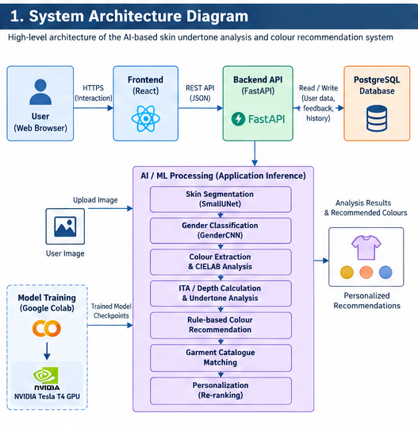
Figure 5.1: System Architecture

5.2 Entity-Relationship Design
The database is designed to maintain user accounts, analysis results, recommendation feedback, and records related to corrections of the auxiliary gender prediction.
The current database design contains four principal entities:
- Users : The users table stores registered user information and selected garment preferences.
- Feedback : The feedback table records user responses to recommended garments. These records provide information that can be used by the personalization component.
- Analysis History : The analysis_history table stores the results of previous skin-colour analyses, including the calculated undertone, depth score, ITA angle, confidence, and recommended colour palette.
- Gender Corrections : The gender_corrections table stores information related to user corrections or confirmations of the auxiliary gender prediction, including the relevant prediction and correction information.
Entity Relationships :
The main relationships in the current design are:
One User can have multiple Feedback records.
One User can have multiple Analysis History records.
One User can have multiple Gender Correction records.
These relationships are established through the user_id foreign-key field.
The complete fields, primary keys, foreign keys, and cardinalities are represented in the ER diagram below.
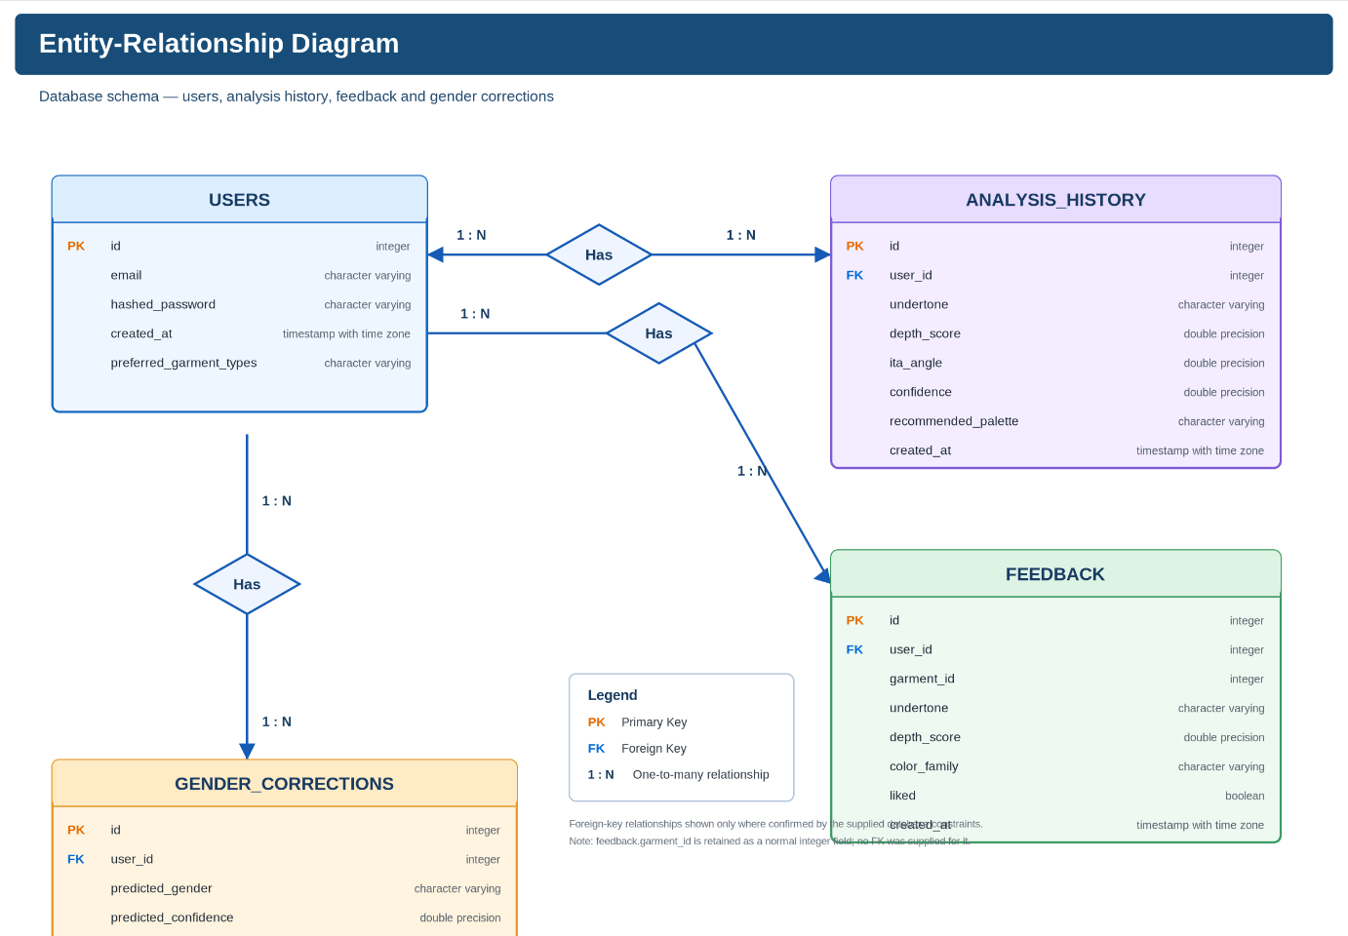
Figure 5.2: ER Diagram

5.3 Use Case Design
The use case design describes the functionality available to users through the web application.
The primary actor represented in the current system is the User.
Authentication :
The user can :
Register an account
Log in
Log out
Image and Analysis :
The user can:
Upload a selfie
Capture a selfie using the camera
View colour-analysis results
Preferences and Recommendations :
The user can:
Set garment-type preferences
Select gender and garment filters
View matched garments
Like or dislike garments
Shuffle recommendations
Retrain recommendations
Open a shopping link
History and Corrections :
The user can:
View analysis history
Delete a history entry
Clear analysis history
Correct the auxiliary gender prediction
Provide consent for photo storage
The use case diagram provides a visual representation of these interactions without describing the internal implementation of each operation.
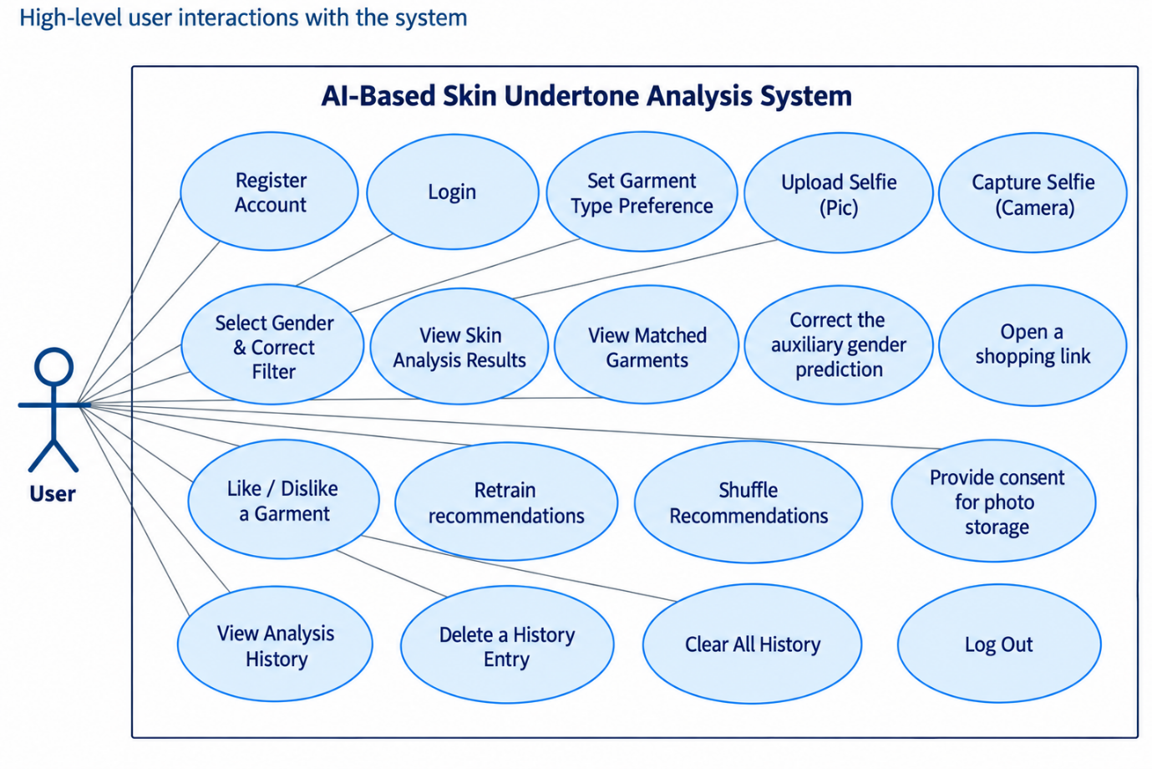
Figure 5.3: Use Case Diagram

5.4 Sequence Design
The sequence design represents the order in which the major components interact during a typical user analysis.
The process begins when the user authenticates with the system. After successful authentication, the user selects the required preferences and uploads or captures a selfie.
The frontend sends the analysis request to the FastAPI backend. The backend processes the image through the ML pipeline. Skin segmentation is performed using the trained segmentation model, followed by colour extraction and calculation of the relevant colour characteristics.
The recommendation components then generate a suitable colour palette and match it with available garments. The resulting analysis is stored in the database and returned to the frontend for display.
The user can subsequently interact with the recommended garments by providing like/dislike feedback. This feedback is stored and can contribute to subsequent personalization.

The overall sequence is : Login → Image Submission → Analysis Request → ML Processing → Colour Analysis → Recommendation → Database Storage → Results → Feedback
The detailed interaction between the User, Frontend, Authentication, Backend API, ML Pipeline, and Database is shown in Figure 5.4.
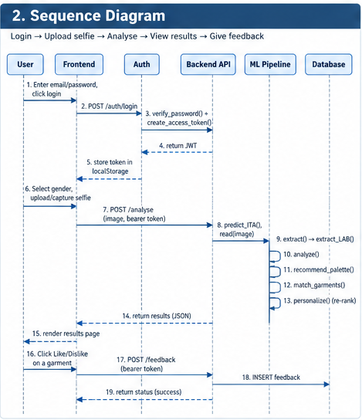
Figure 5.4: Sequence Diagram

5.5 Class and Module Design
The AI and recommendation functionality is divided into separate modules. This modular organization separates model training, image processing, recommendation generation, and personalization.
- SmallUNet :
SmallUNet is the segmentation model responsible for identifying the relevant skin region from an input image.
- CelebAMaskHQDataset :
CelebAMaskHQDataset provides the dataset-handling functionality used during segmentation-model training.
- GenderCNN :
GenderCNN is an auxiliary convolutional neural-network component used for gender-related prediction.
- GenderDataset :
GenderDataset handles the data used for the development and evaluation of the auxiliary classifier.
- ColorExtractor :
ColorExtractor performs skin-pixel sampling and the colour-analysis operations required to obtain the skin-colour characteristics used by the recommendation system.
- RulesEngine :
RulesEngine generates the recommended colour palette using the calculated skin-colour information.
- CatalogMatcher :
CatalogMatcher matches the generated colour recommendations with available garment catalogue items and applies the relevant garment filters.
- PreferenceMLP :
PreferenceMLP provides the learned personalization component for modelling user preferences from available feedback.
- Reranker :
Reranker uses the available preference information to adjust the ordering of recommendation candidates.
The relationships between these models, datasets, processing modules, and recommendation components are represented in the class diagram.
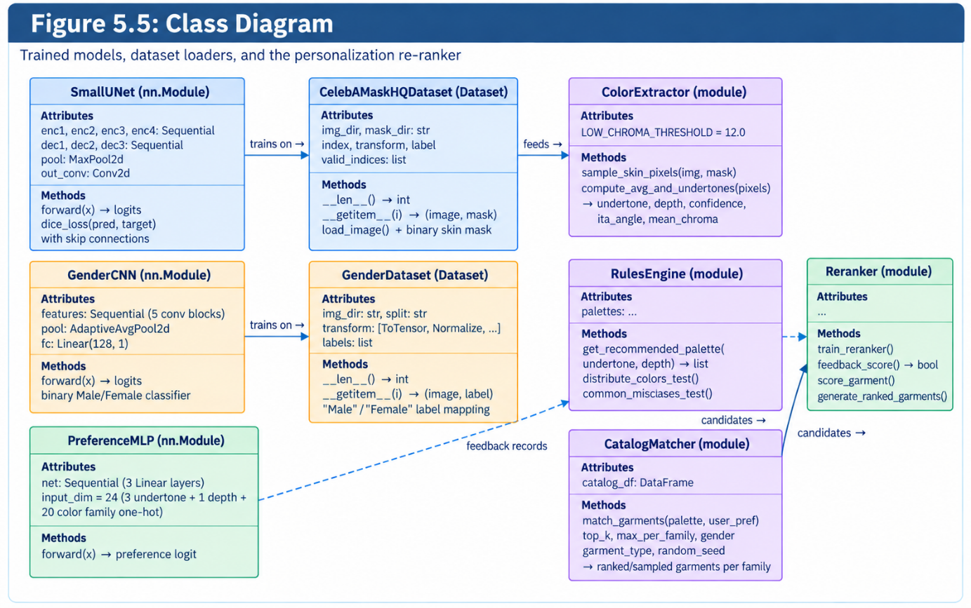
Figure 5.5: Class Diagram

5.6 Overall Design Summary
The proposed system combines a web-based application with an AI-assisted colour-analysis and recommendation pipeline.
During normal application use, the process begins at the React frontend and is handled by the FastAPI backend. The submitted image is processed by the AI and colour-analysis components, after which the recommendation modules identify suitable colours and garments. User feedback and analysis results are stored in PostgreSQL.
The main runtime architecture can therefore be summarized as:
User
↓
React Frontend
↓
FastAPI Backend
↓
Skin Segmentation and Colour Analysis
↓
Undertone / Depth Analysis
↓
Colour Recommendation
↓
Garment Catalogue Matching
↓
Personalization / Re-Ranking
↓
Results
↓
Feedback and History Storage
The separate model-development process is : Dataset → Google Colab → Tesla T4 GPU → PyTorch Training → Trained Model → Application Inference
This separation keeps model training independent from the live application while allowing the trained models to be used during runtime analysis.

Chapter 6

IMPLEMENTATION AND RESULTS

6.1 Backend Implementation
The AI-BASED SKIN UNDERTONE ANALYSIS AND PERSONALIZED FASHION COLOUR RECOMMENDATION SYSTEM is implemented with a FastAPI backend. The backend handles user registration and authentication, image upload and analysis, AI-based skin segmentation, colour analysis, fashion colour recommendation, catalogue matching, personalization, feedback, and analysis-history management.
The implementation is divided into separate modules for authentication, database access, model inference, image calibration, colour extraction, recommendation rules, catalogue matching, and personalization. This separation keeps the main API layer responsible for coordinating the processing stages rather than implementing every operation in a single function.
Authentication and Security :
The system uses JWT-based authentication. Passwords are stored as bcrypt hashes, while the authentication token contains the authenticated user's identifier and expiration information.
The essential part of token generation is shown below:

def create_access_token(user_id):
expire = datetime.now(timezone.utc) + timedelta(
minutes=ACCESS_TOKEN_EXPIRE_MINUTES
)

payload = {
"sub": str(user_id),
"exp": expire
}

return jwt.encode(
payload,
SECRET_KEY,
algorithm=ALGORITHM
)

The protected API requests are validated through the current-user dependency. The dependency decodes the bearer token, obtains the user identifier, and retrieves the corresponding user record.

payload = jwt.decode(
token,
SECRET_KEY,
algorithms=[ALGORITHM]
)

user_id = int(payload.get("sub"))

user = db.query(User).filter(
User.id == user_id
).first()

if user is None:
raise credentials_exception

return user

This mechanism is used to associate analysis, feedback, preferences, and history operations with the authenticated user.

Image Analysis Implementation :
The /analyze endpoint acts as the main processing interface of the system. It receives an uploaded image and coordinates the complete analysis workflow.

@app.post("/analyze")
async def analyze(
file: UploadFile = File(...),
current_user: User = Depends(get_current_user),
db: Session = Depends(get_db),
):

After image preprocessing, the backend performs skin-pixel extraction and colour analysis:
corrected_image = gray_world_white_balance(image_np)

skin_pixels = sample_skin_pixels(
corrected_image,
mask_np,
max_samples=2000
)

analysis = compute_ita_and_undertone(
skin_pixels
)
The resulting colour characteristics are then used to generate a recommended palette and identify suitable garments:
palette = get_recommended_palette(
undertone=analysis["undertone"],
depth_score=analysis["depth_score"],
)

matched = match_garments(
recommended_palette=palette,
catalog_csv_path=CATALOG_CSV,
top_n=30,
gender=gender,
garment_types=resolved_garment_types,
)

The backend subsequently applies personalization, adds shopping links, and stores the completed analysis in the user's history.

6.2 API Endpoints Summary
The backend exposes REST API endpoints for authentication, user preferences, image analysis, recommendation feedback, personalization, history management, and gender-related feedback.
Method | Endpoint | Purpose | Authentication
POST | /auth/register | Register a new user | No
POST | /auth/login | Authenticate a user and issue an access token | No
GET | /auth/me | Retrieve authenticated user information | Yes
PATCH | /auth/preferences | Update garment preferences | Yes
POST | /analyze | Analyse an image and generate recommendations | Yes
POST | /feedback | Store user feedback for a recommendation | Yes
POST | /retrain-reranker | Update the personalization model using available feedback | Yes
POST | /reshuffle | Generate a different recommendation ordering | Yes
GET | /history | Retrieve the user’s analysis history | Yes
DELETE | /history/{history_id} | Delete a selected history record | Yes
DELETE | /history | Delete the user’s analysis history | Yes
POST | /gender-feedback | Submit feedback or correction for the auxiliary gender prediction | Yes
Table 6.1 : API Endpoints Summary
The endpoints form the communication layer between the React frontend and the FastAPI backend. The /analyze operation is the central application service, while the other endpoints support authentication, preference management, personalization, and storage-related functionality.

6.3 AI Model Implementation
The system uses deep-learning models for image-based processing. The main segmentation model is SmallUNet, which identifies the skin region required for subsequent colour analysis. The project also contains GenderCNN as an auxiliary gender-classification component.
SmallUNet :
SmallUNet is a compact encoder-decoder segmentation network with convolutional blocks, pooling, transpose-convolution layers, and skip connections.
Only the essential architectural definition is shown below:

self.enc1 = conv_block(3, 16)
self.enc2 = conv_block(16, 32)
self.enc3 = conv_block(32, 64)
self.enc4 = conv_block(64, 128)

self.pool = nn.MaxPool2d(2)

self.up3 = nn.ConvTranspose2d(
128, 64, kernel_size=2, stride=2
)
self.up2 = nn.ConvTranspose2d(
64, 32, kernel_size=2, stride=2
)
self.up1 = nn.ConvTranspose2d(
32, 16, kernel_size=2, stride=2
)

self.out_conv = nn.Conv2d(
16, 1, kernel_size=1
)
The corresponding decoder reuses encoder features through skip connections:
d3 = self.dec3(
torch.cat([self.up3(e4), e3], dim=1)
)

d2 = self.dec2(
torch.cat([self.up2(d3), e2], dim=1)
)

d1 = self.dec1(
torch.cat([self.up1(d2), e1], dim=1)
)
The model produces the skin segmentation mask used by the colour-analysis stage.
The current application loads the trained checkpoint for inference, while the model-training process was carried out separately in Google Colab using the NVIDIA Tesla T4 environment. The training environment is therefore distinct from the deployed application inference path.

6.4 Colour Analysis and Recommendation Implementation
After segmentation, the detected skin pixels are sampled and processed for colour analysis. The implementation converts the sampled pixels into CIELAB colour space and calculates ITA, depth, chroma, hue direction, undertone, and confidence.
ITA and Undertone Calculation :
The central portion of the colour-analysis implementation calculates the ITA value from the L* and b* components:

b_safe = np.where(
np.abs(b_star) < 1e-6,
1e-6,
b_star
)

ita_per_pixel = (
np.arctan(
(l_star - 50.0) / b_safe
) * (180.0 / math.pi)
)

avg_ita = float(
np.mean(ita_per_pixel)
)

Undertone is determined using hue direction and circular statistics rather than a simple arithmetic average of angles:

hue_rad = np.arctan2(
b_star,
a_star
)

mean_sin = float(
np.mean(np.sin(hue_rad))
)

mean_cos = float(
np.mean(np.cos(hue_rad))
)

avg_hue = float(
np.degrees(
np.arctan2(
mean_sin,
mean_cos
)
)
)

The resulting hue is mapped to the implemented undertone categories:

if avg_hue > 50.0:
undertone = "Warm"
elif avg_hue < 25.0:
undertone = "Cool"
else:
undertone = "Neutral"

The implementation also includes a chroma safeguard. When the mean chroma is below the configured threshold of 12.0, the system reports an uncertain undertone and limits confidence rather than producing a misleadingly strong classification.
Colour Recommendation Rules :
The resulting undertone and depth score are passed to the rules engine:

palette = get_recommended_palette(
undertone=analysis["undertone"],
depth_score=analysis["depth_score"]
)

The rules engine then selects the appropriate colour family set for the analysed result. The recommendation process is therefore deterministic before the later personalization stage is applied

6.5 Recommendation and Personalization Implementation
The recommendation stage combines catalogue matching with optional user-specific personalization.
The catalogue matcher first restricts the available records according to the recommendation palette and applicable garment filters:

df_filtered = df[
df["color_family"].isin(
recommended_palette
)
].copy()

palette_rank = {
color: i
for i, color in enumerate(
recommended_palette
)
}

Specific garments are then sampled from the available colour families to create the candidate set. The implementation uses a wider candidate pool before personalization and reduces the final result after reranking.
Personalization :
The personalization component represents the undertone, depth score, and garment colour family as a 24-dimensional feature vector. The essential model definition is:

self.net = nn.Sequential(
nn.Linear(input_dim, hidden_dim),
nn.ReLU(),
nn.Linear(hidden_dim, hidden_dim),
nn.ReLU(),
nn.Linear(hidden_dim, 1),
)

The model is trained from the user's feedback records. Training is not performed until at least five feedback records are available:

if len(feedback_records) < 5:
return False

During reranking, the implementation only scores colour families for which the user has actual feedback:

if (
trained_families
and color_family not in trained_families
):
untouched_group.append(
dict(garment)
)
continue

This restriction prevents unsupported personalization across colour families for which the user has not provided evidence.

6.6 Database and Security Implementation
The system uses SQLAlchemy for database operations and supports PostgreSQL as the primary database configuration. A local SQLite configuration is also available for development and testing when PostgreSQL is not configured.
The principal tables are:
- users
- feedback
- analysis_history
- gender_corrections
The user table stores account information and preferences, while feedback records connect recommendation interactions to the corresponding user. Analysis-history records store important results such as undertone, depth score, ITA angle, confidence, and the recommended palette.
A representative database relationship is:

user_id = Column(
Integer,
ForeignKey("users.id"),
nullable=False,
index=True
)

Using the authenticated user_id ensures that stored feedback and analysis records remain associated with the correct account. History queries and deletion operations likewise apply user-specific filtering.
The system also contains consent-gated image storage for gender-feedback data. An image is written to storage only when explicit consent has been provided.

6.7 Frontend Implementation
The frontend is implemented using React 19.1.0, with Vite 6.3.5 used as the development and build tool. Client-side navigation uses react-router-dom 7.6.2. The frontend contains dedicated pages for registration, login, analysis, results, history, and settings.
Application Routing
The main application maintains the analysis result and uploaded image in state so that the Results page can display the completed analysis:

const [analysisData, setAnalysisData] =
useState(null);

const [analysisImage, setAnalysisImage] =
useState(null);

The protected Analysis route is defined using the ProtectedRoute component:
<Route
path="/analyze"
element={
<ProtectedRoute>
<Analyze
onAnalysisComplete={
setAnalysisData
}
onImageCapture={
setAnalysisImage
}
/>
</ProtectedRoute>
}
/>

The same protected-route pattern is used for Results, History, and Settings pages. The frontend therefore separates public authentication pages from application functionality that requires an authenticated session.
Protected Route
The essential access-control logic checks whether a stored authentication token is available:

const token =
localStorage.getItem(
"chromafit_token"
);

if (!token) {
return (
<Navigate
to="/login"
replace
/>
);
}

return children;

This component prevents direct access to protected pages when the user has not authenticated. The frontend implementation also includes automated tests for this protected-route behaviour.

6.8 Screenshots
The following section presents the major user-interface screens of the AI-BASED SKIN UNDERTONE ANALYSIS AND PERSONALIZED FASHION COLOUR RECOMMENDATION SYSTEM. These screens represent the main user flow from account creation and authentication through image analysis, recommendation results, history management, and settings.

Figure 6.1: Registration Page
The Registration page provides the interface for creating a new user account. The page contains the registration fields and validation feedback required during account creation. The frontend validates the supplied information before submitting the registration request to the backend. After successful registration, the user can proceed to the main application workflow.


Figure 6.2: Login Page
The Login page provides the authentication interface for existing users. The entered credentials are submitted to the backend authentication service. After successful authentication, the returned access token is stored by the frontend and used for subsequent protected requests.
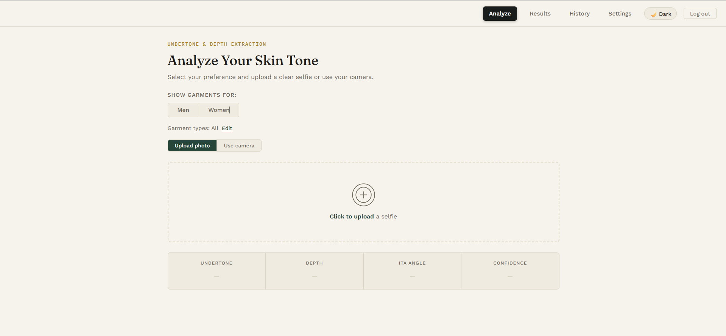
Figure 6.3: Analyze Page
The Analyze page provides the main image-input interface of the system. The user can provide an image for skin and colour analysis using the available upload or camera functionality. The selected image is submitted to the backend /analyze endpoint, where the complete analysis pipeline is executed.

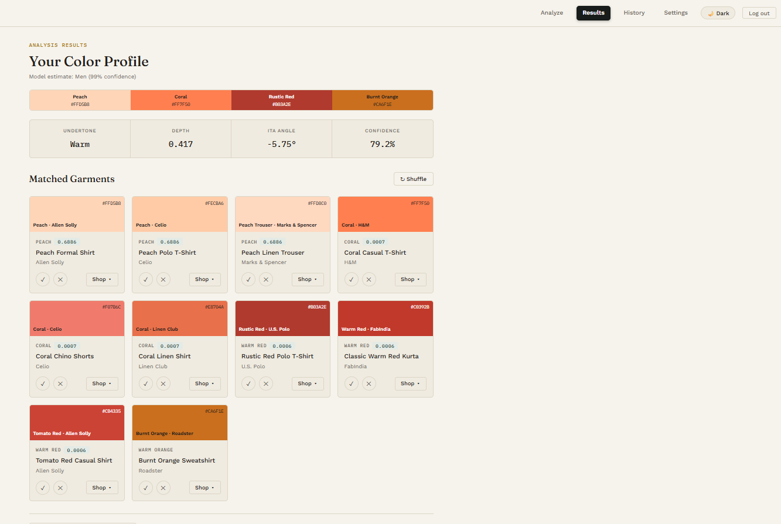
Figure 6.4: Results Page
The Results page presents the output generated from the completed analysis. It displays the calculated skin-colour information, recommended colour palette, and matched garment recommendations returned by the backend. The page also provides the available recommendation interaction functionality, including feedback and reshuffling where applicable.

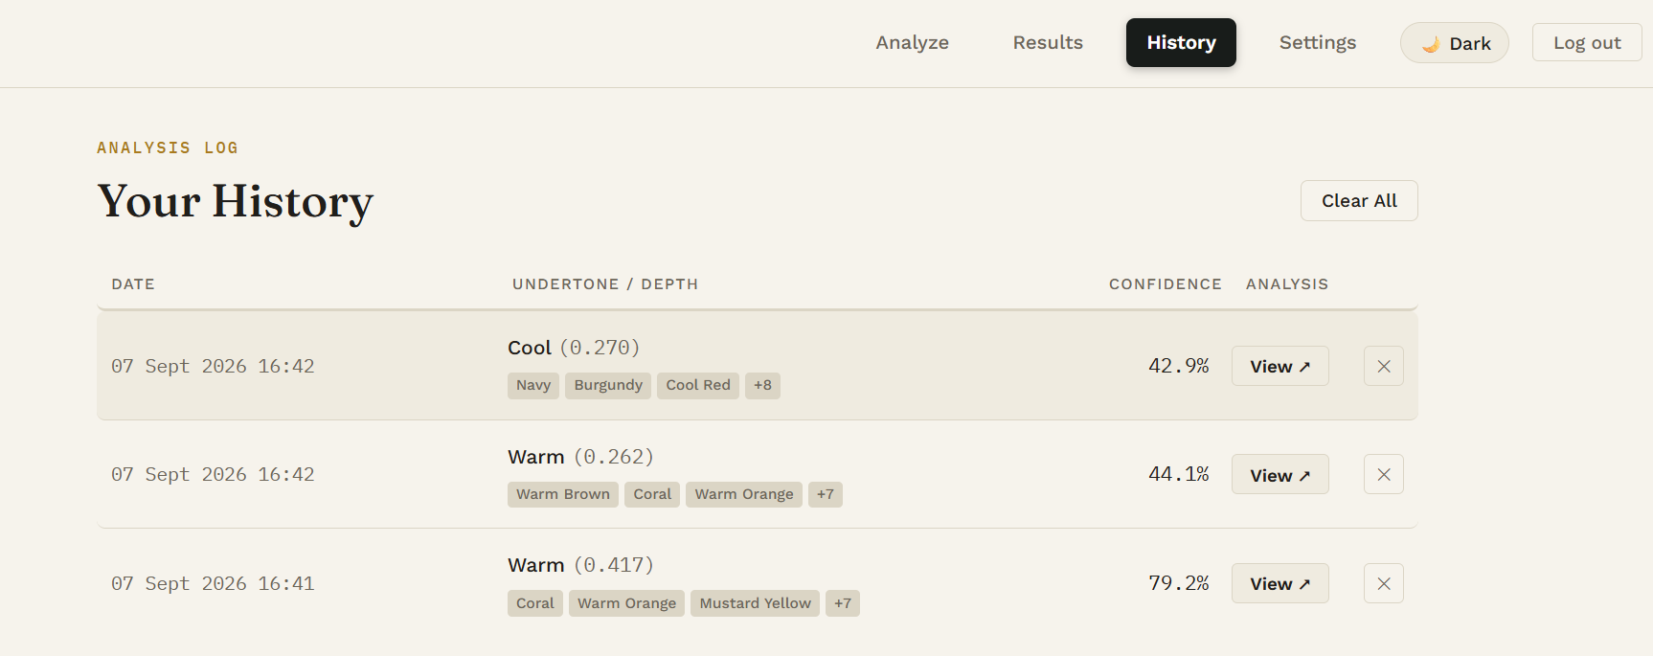Figure 6.5: History Page
The History page displays previous analyses associated with the authenticated user. Each stored record provides information such as the analysis date, undertone, depth value, and confidence. Individual history records can be deleted, and the application also provides an option to clear the user's stored analysis history.

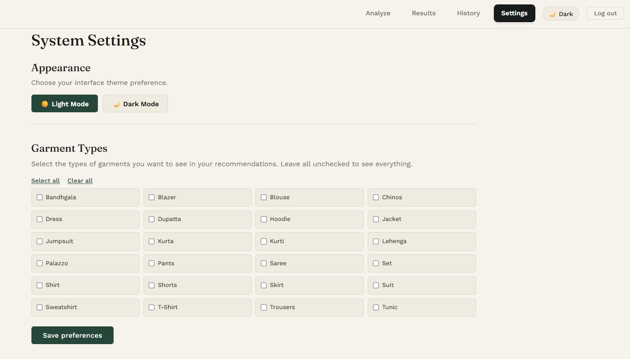
Figure 6.6: Settings Page
The Settings page provides the interface for managing the user's garment-type preferences. The selected preferences are sent to the backend and stored against the authenticated user's account. These preferences can then be considered when the system filters garment recommendations.

Chapter 7

TESTING

7.1 Unit Testing
Unit testing is the process of validating individual software components to ensure that they perform their intended functions correctly. In the AI-BASED SKIN UNDERTONE ANALYSIS AND PERSONALIZED FASHION COLOUR RECOMMENDATION SYSTEM, testing was performed across both the backend and frontend layers.
The backend testing suite was implemented using pytest and FastAPI's TestClient. The tests execute against a temporary, isolated SQLite database so that test execution does not affect the application's actual database. The frontend testing suite was implemented using Vitest and React Testing Library and validates input-validation utilities, colour-contrast calculations, notification rendering, and protected-route behaviour.
Automated testing was complemented by manual verification of the complete image-analysis workflow because the actual machine-learning inference pipeline depends on trained model weights and real input images. The integrated verification covered the image-processing pipeline, recommendation behaviour, personalization, user isolation, and other functional areas.

Benefits of Unit Testing in the Proposed System
Unit testing provides an early mechanism for identifying defects in authentication, data handling, validation, personalization, and frontend behaviour. It also helps verify that corrections made during development do not introduce regressions into previously working functionality.
Another important benefit is that the tests document the expected behaviour of the implemented system. For example, the backend suite explicitly verifies that unauthenticated requests are rejected, preferences are persisted correctly, sufficient feedback allows reranker training, and one user's history cannot be accessed through another user's account.

7.2 Backend Unit Tests
The backend test suite uses pytest together with FastAPI's TestClient. The test environment creates a temporary SQLite database for each test execution, allowing the tests to be repeated without modifying production data. A total of 15 backend tests were executed and all 15 passed successfully.
The tests cover five main areas: authentication, protected-endpoint authorization, user-preference persistence, feedback and reranker retraining, and multi-user analysis-history isolation.
- Authentication Testing : The authentication tests verify successful registration, rejection of duplicate email addresses, successful login using valid credentials, rejection of an incorrect password, and rejection of a login attempt for a non-existent account. These tests confirm that both the normal authentication path and important failure conditions behave as expected.
- Protected Endpoint Testing : The backend also verifies that operations requiring authentication cannot be accessed without a valid token. Separate tests cover the history, feedback, reranker-retraining, and preference-update endpoints.
- Preference and Personalization Testing : The preference test verifies that garment-type preferences can be saved and subsequently retrieved through the authenticated account. The personalization tests also verify both the insufficient-feedback case and successful reranker training when sufficient feedback has been collected.
- Multi-User History Isolation : The multi-user isolation test is an important security test in the backend suite. It verifies that analysis-history records belonging to one user cannot be viewed or modified through another user's account. Additional tests verify correct handling of non-existent history records and clearing an already-empty history collection.
Test ID | Test Purpose | Result
BT-001 | Successful user registration | Passed
BT-002 | Duplicate email registration rejection | Passed
BT-003 | Successful login with valid credentials | Passed
BT-004 | Incorrect password rejection | Passed
BT-005 | Non-existent email rejection | Passed
BT-006 | Authentication required for history access | Passed
BT-007 | Authentication required for feedback | Passed
BT-008 | Authentication required for reranker retraining | Passed
BT-009 | Authentication required for preference updates | Passed
BT-010 | Preference save and retrieval | Passed
BT-011 | Reranker behaviour with insufficient feedback | Passed
BT-012 | Successful feedback logging and reranker training | Passed
BT-013 | Analysis-history isolation between users | Passed
BT-014 | Non-existent history deletion returns the correct error | Passed
BT-015 | Clearing empty history completes successfully | Passed

Table 7.1 : Backend Unit Testing Results

7.3 Frontend Unit Tests
The frontend testing suite uses Vitest with React Testing Library for component-level verification. The tests operate on the actual frontend implementation and cover validation functions, colour-contrast calculation, notification rendering, and protected-route behaviour.
A total of 20 frontend tests were executed and all 20 passed successfully.
- validators.test.js : This test suite contains 10 tests for the frontend validation utilities. The tests verify password-strength scoring and email-format validation, including invalid email structures and embedded spaces.
- contrastText.test.js : This suite contains 5 tests for the WCAG-based text-contrast calculation used by the frontend. The tests verify that suitable black or white text is selected for different background colours, including a documented boundary case.
- Toast.test.jsx : This suite contains 3 tests covering the Toast component. The tests verify message rendering, empty-state behaviour, and automatic dismissal timing.
- ProtectedRoute.test.jsx : This suite contains 2 tests for the protected-route component. The first verifies that unauthenticated users are redirected to /login, while the second verifies that protected content is rendered when an authentication token is present.

Test File | Test Count | Main Coverage | Result
validators.test.js | 10 | Password scoring and email validation | 10/10 Passed
contrastText.test.js | 5 | WCAG contrast-ratio calculations | 5/5 Passed
Toast.test.jsx | 3 | Message rendering and auto-dismiss behaviour | 3/3 Passed
ProtectedRoute.test.jsx | 2 | Authentication redirect and protected rendering | 2/2 Passed

Table 7.2 : Frontend Component Testing Results

The combination of backend and frontend automated testing provides 35 successful automated tests in total, while the complete AI-analysis workflow was additionally verified through manual integrated testing using real model weights and real images.

Chapter 8

CONCLUSION AND FUTURE ENHANCEMENTS

8.1 Summary
The AI-BASED SKIN UNDERTONE ANALYSIS AND PERSONALIZED FASHION COLOUR RECOMMENDATION SYSTEM demonstrates how artificial intelligence, image processing, colour science, and personalized recommendation techniques can be integrated into a single application for fashion colour guidance. The system accepts an image from the user, identifies the relevant skin region, analyses skin colour characteristics, determines undertone and depth information, and generates a suitable fashion colour palette.
The skin-analysis pipeline uses a trained SmallUNet segmentation model to isolate skin regions before colour analysis. The extracted pixels are processed using gray-world white balancing and converted to CIELAB colour space. The system calculates ITA, depth score, chroma, hue-related information, undertone, and confidence, with a low-chroma safeguard for cases where the available colour information is insufficient for a reliable undertone decision.
The recommendation stage combines a deterministic rules engine with catalogue matching. The identified undertone and depth score are used to generate a recommended colour palette, after which suitable garments are selected from the available catalogue. User preferences such as garment type can also be applied to the recommendation process.
The system further extends the basic recommendation approach through a feedback-based personalization mechanism. The PreferenceMLP and reranking components use user feedback to influence the ordering of suitable recommendations. The personalization process is deliberately restricted to colour families supported by actual user feedback, reducing unsupported extrapolation when insufficient preference information is available.
The application also includes user authentication, persistent analysis history, preference management, feedback collection, and an auxiliary GenderCNN prediction component. JWT-based authentication and bcrypt password hashing provide the primary application security mechanisms, while user-specific database filtering maintains separation between individual accounts.
From a software-engineering perspective, the project was evaluated through automated backend and frontend testing. The backend test suite recorded 15 successful tests out of 15, while the frontend suite recorded 20 successful tests out of 20. Additional manual verification was used for the complete image-analysis and recommendation workflow because the integrated AI pipeline requires trained model checkpoints and real image inputs.
Overall, the system provides an end-to-end implementation that connects image analysis with practical fashion colour recommendations while maintaining explicit handling of uncertainty, personalization constraints, user data isolation, and the distinction between model training and application inference.

8.2 Future Enhancements
The current implementation provides a functional foundation for AI-based skin undertone analysis and personalized fashion colour recommendation. The following enhancements represent logical extensions of the existing system.
- Improved Real-World Image Robustness: Further improvement of the segmentation and colour-analysis models using a wider range of real-world images, lighting conditions, camera devices, and backgrounds could improve performance outside controlled or development datasets.
- Larger and More Diverse Training Data: Additional training data covering broader variations in skin appearance, illumination, image quality, and demographic characteristics could improve model generalization and reduce domain-shift effects observed during real-world evaluation.
- Advanced Colour Recommendation: Future versions could extend the existing rules-based palette generation with a richer colour knowledge base, allowing recommendations to consider additional properties such as colour combinations, contrast, and coordinated outfit palettes.
- Improved Personalization: The existing feedback-based reranker could be extended to learn more detailed user preferences over time, including preferences for particular garment types, colour families, and recommendation patterns when sufficient feedback becomes available.
- More Comprehensive Catalogue Integration: The catalogue-matching component could be expanded to support larger and dynamically updated garment catalogues, providing a broader selection of clothing items and more varied recommendations.
- Enhanced Image Quality Handling: Future versions could include explicit detection and handling of poor-quality, very dark, overexposed, blurred, or unsuitable images before analysis so that users receive clearer guidance when the input image cannot support reliable colour estimation.
- Model Deployment Optimization: The inference pipeline could be optimized further for faster execution and more efficient deployment, particularly for environments with limited computational resources.
- Explainable Recommendations: The recommendation interface could provide a clearer explanation of why a particular colour family or garment was selected, linking the recommendation to the detected undertone, depth, and user feedback.
- Extended Feedback Mechanisms: Feedback could be expanded beyond simple preference signals to include more detailed user responses about recommendation usefulness, allowing future versions of the personalization model to learn from richer interaction data.
- Additional User Interfaces: Dedicated mobile applications or a more extensively optimized mobile interface could make image capture and recommendation access more convenient on smartphones and tablets.

8.3 Limitations
The current version of the AI-BASED SKIN UNDERTONE ANALYSIS AND PERSONALIZED FASHION COLOUR RECOMMENDATION SYSTEM has several limitations that are acknowledged for transparency.
- Dependence on Image Quality: The reliability of the colour-analysis result depends on the quality of the submitted image. Illumination, white balance, camera characteristics, shadows, and other imaging conditions can affect the colour information available for analysis.
- Real-World Domain Shift: Although the skin-segmentation model achieved strong validation performance during development, evaluation on real-world phone-selfie images showed lower performance. This indicates that performance on controlled or development data does not necessarily translate directly to every real-world image condition.
- GenderCNN Reliability: The GenderCNN is an auxiliary component rather than an authoritative decision mechanism. The difference between its validation performance and real-world phone-selfie performance means that its prediction should not be treated as universally reliable. Explicit user selection remains important where gender-based garment filtering is required.
- Undertone Uncertainty: Some images do not provide sufficient colour information for a confident undertone classification. The system therefore includes a low-chroma safeguard that can return an “Uncertain” result and reduce the confidence value instead of forcing a strong classification.
- Catalogue Dependence: The quality and variety of garment recommendations depend on the available catalogue data. A limited catalogue naturally restricts the number and diversity of suitable garments that can be presented.
- Limited Personalization Data: The personalization model requires sufficient user feedback before meaningful user-specific reranking can be performed. With limited feedback, the system relies more heavily on the general recommendation rules.
- Offline Training and Application Inference Separation: The model-training process and application inference environment are separate. Training was performed using Google Colab with an NVIDIA Tesla T4, while the current backend performs inference using the CPU. This means the training hardware itself is not part of the live application runtime.
- Auxiliary Prediction Scope: The GenderCNN output is intended as supporting information and should not be interpreted as a definitive representation of a user's identity or preference. Its role within the system is deliberately limited.
Despite these limitations, the system provides a complete implemented pipeline from image input and AI-based segmentation through colour analysis, recommendation generation, personalization, and persistent user interaction. The identified limitations provide clear directions for improving model robustness, recommendation quality, personalization, and real-world usability in future versions.

REFERENCES

- FastAPI, “FastAPI Documentation — Modern, Fast Web Framework for Building APIs with Python,” Sebastián Ramírez.
Available at: https://fastapi.tiangolo.com/
- Meta Platforms, Inc., “React Documentation — The Library for Web and Native User Interfaces.”
Available at: https://react.dev/
- PyTorch Contributors, “PyTorch Documentation,” PyTorch Foundation.
Available at: https://docs.pytorch.org/docs/
- F. Chollet et al., “Keras: Deep Learning for Humans,” Keras Documentation.
Available at: https://keras.io/
- O. Ronneberger, P. Fischer, and T. Brox, “U-Net: Convolutional Networks for Biomedical Image Segmentation,” in Medical Image Computing and Computer-Assisted Intervention (MICCAI), 2015, pp. 234–241.
- C.-H. Lee, Z. Liu, L. Wu, and P. Luo, “MaskGAN: Towards Diverse and Interactive Facial Image Manipulation,” in Proceedings of the IEEE/CVF Conference on Computer Vision and Pattern Recognition Workshops, 2020.
- T. Lee, S. Lee, and others, “CelebAMask-HQ: A Large-Scale Face Parsing Dataset,” in Proceedings of the IEEE/CVF Conference on Computer Vision and Pattern Recognition Workshops, 2020.
- International Commission on Illumination (CIE), “Colorimetry,” CIE Publication 15:2018, 4th Edition, Vienna, Austria, 2018.
- C. D. McCamy, H. Marcus, and J. G. Davidson, “A Color-Rendition Chart,” Journal of Applied Photographic Engineering, vol. 2, no. 3, pp. 95–99, 1976.
- D. L. MacAdam, “Visual Sensitivities to Color Differences in Daylight,” Journal of the Optical Society of America, vol. 32, no. 5, pp. 247–250, 1942.
- scikit-image Development Team, “scikit-image Documentation — Image Processing in Python.” Available at: https://scikit-image.org/docs/
- Python Software Foundation, “Python 3 Documentation.”
Available at: https://docs.python.org/3/
- PostgreSQL Global Development Group, “PostgreSQL Documentation.”
Available at: https://www.postgresql.org/docs/
- SQLAlchemy Contributors, “SQLAlchemy Documentation — Python SQL Toolkit and Object Relational Mapper.”
Available at: https://docs.sqlalchemy.org/en/20/
- Pillow Contributors, “Pillow Documentation — Python Imaging Library.”
Available at: https://pillow.readthedocs.io/
- NumPy Developers, “NumPy Documentation.”
Available at: https://numpy.org/doc/
- Pandas Development Team, “pandas Documentation.”
Available at: https://pandas.pydata.org/docs/
- S. A. K. R. et al., “Image-Based Skin Tone and Color Analysis for Personalized Applications,” relevant computer-vision and colour-analysis literature consulted during system development.
- M. Jones, J. Bradley, and N. Sakimura, “JSON Web Token (JWT),” RFC 7519, Internet Engineering Task Force, May 2015.
Available at: https://www.rfc-editor.org/rfc/rfc7519
- OWASP Foundation, “OWASP Top 10: The Ten Most Critical Web Application Security Risks,” Open Web Application Security Project.
Available at: https://owasp.org/www-project-top-ten/
- bcrypt Project, “bcrypt Password Hashing Documentation.”
Available at: https://pypi.org/project/bcrypt/
- Vite Team, “Vite Documentation — Next Generation Frontend Tooling.”
Available at: https://vite.dev/
- Vitest Team, “Vitest Documentation — A Vite-Powered Testing Framework.”
Available at: https://vitest.dev/
- React Testing Library Contributors, “React Testing Library Documentation.”
Available at: https://testing-library.com/docs/react-testing-library/intro/

